**Location** -

Metro - 50% - skewed to Delhi NCR

**Age Group** :

* 16+ children have avg parent age 49

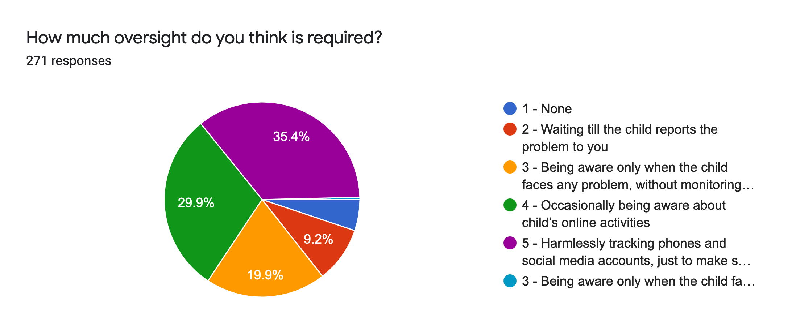

*85.6% feel monitoring is required.  
*87.7% (In metros)

*83% mothers

*89% fathers

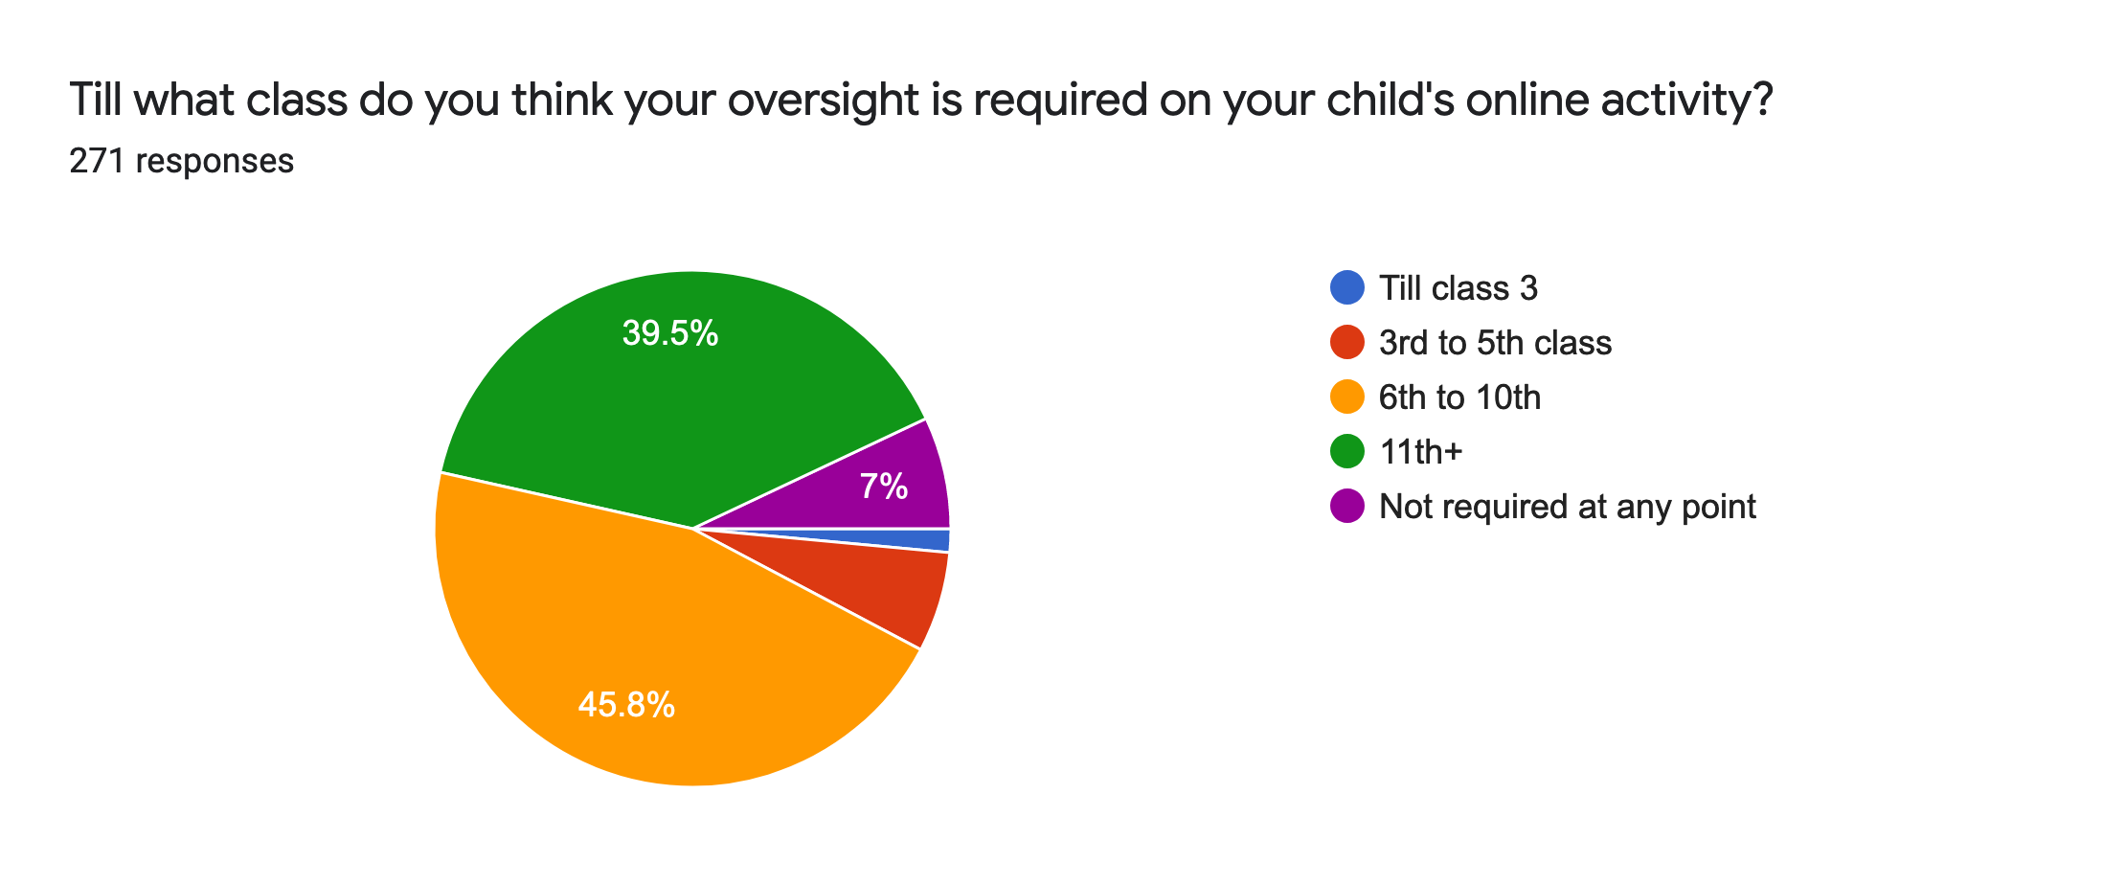

*45% feel 6-10th class in metros. (For kids > 8 too)

**50% of people are not sure or feel they won’t come to them if their kids face any issue. (metro/non-metro)**

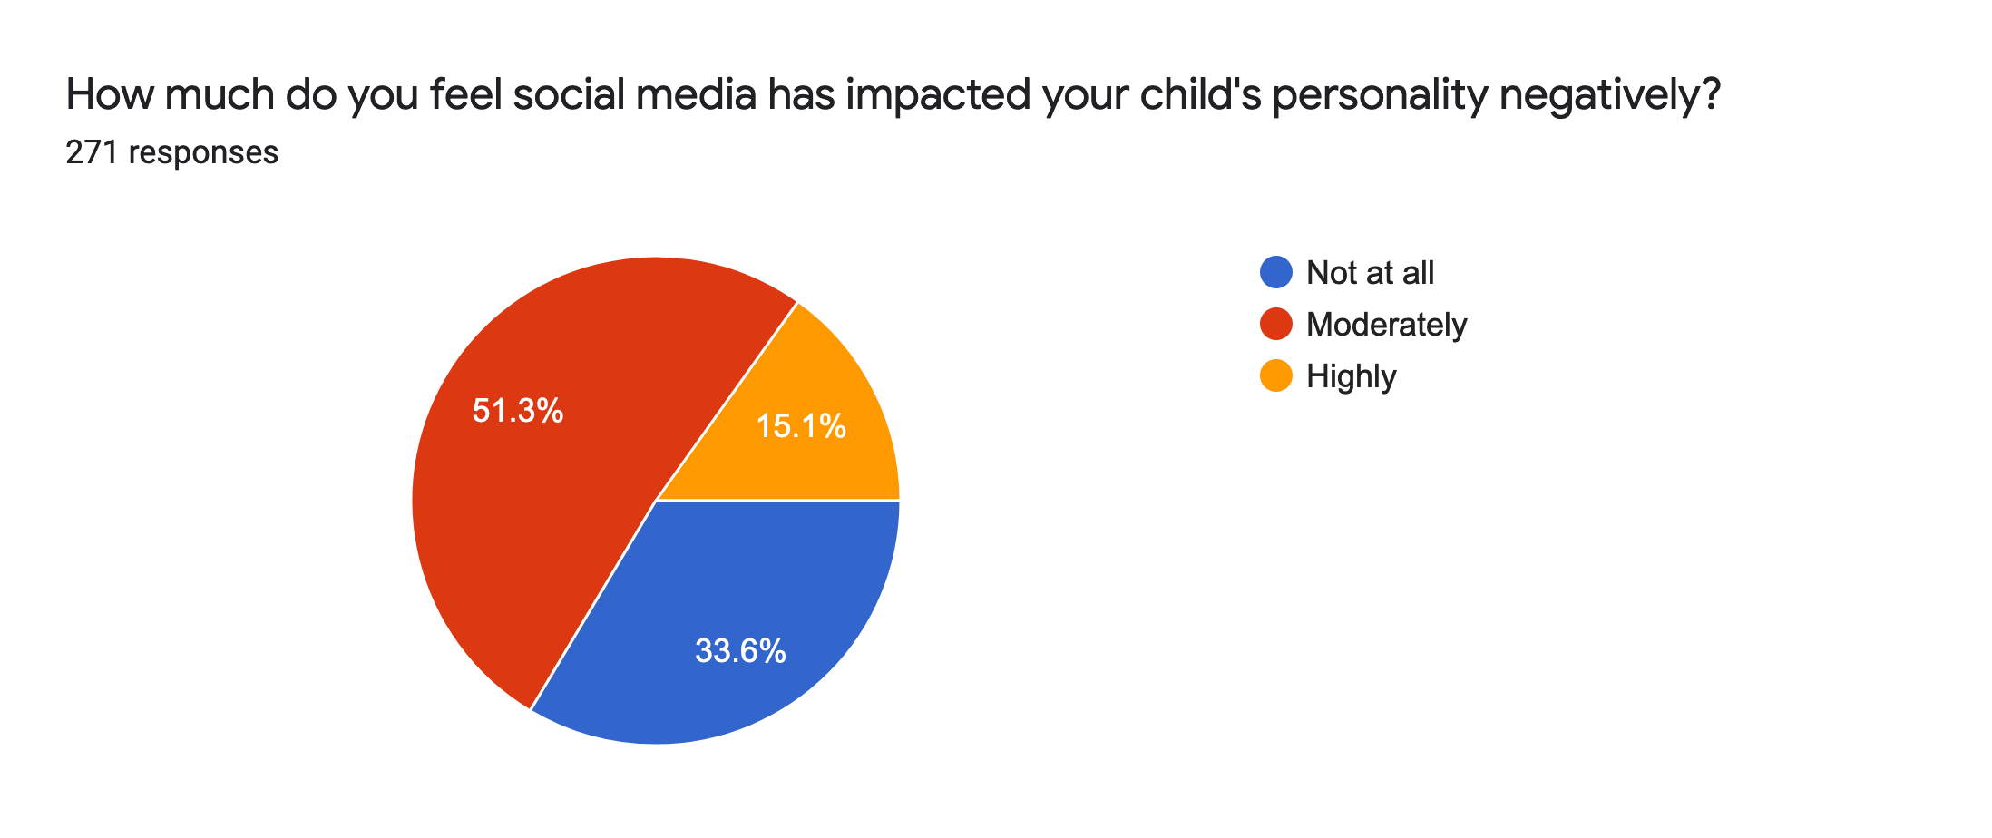

* This is even true for kids > 8yrs

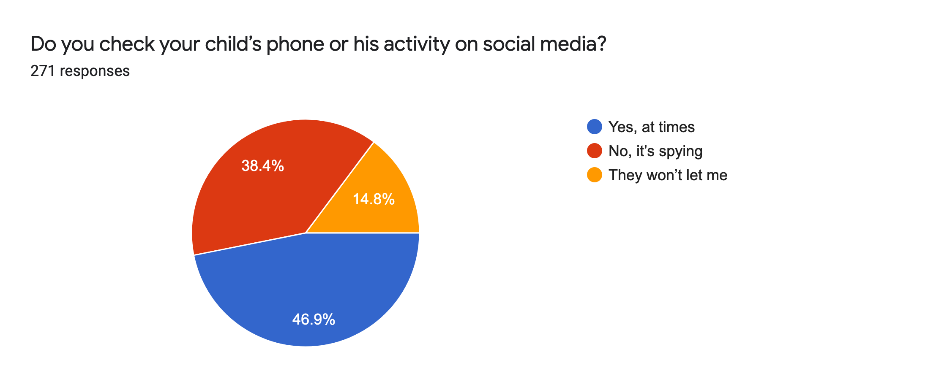

*40% feel its spying for ages > 6 (Same for metros)

31% mothers feel it’s spying

45.8% fathers feels it’s spying

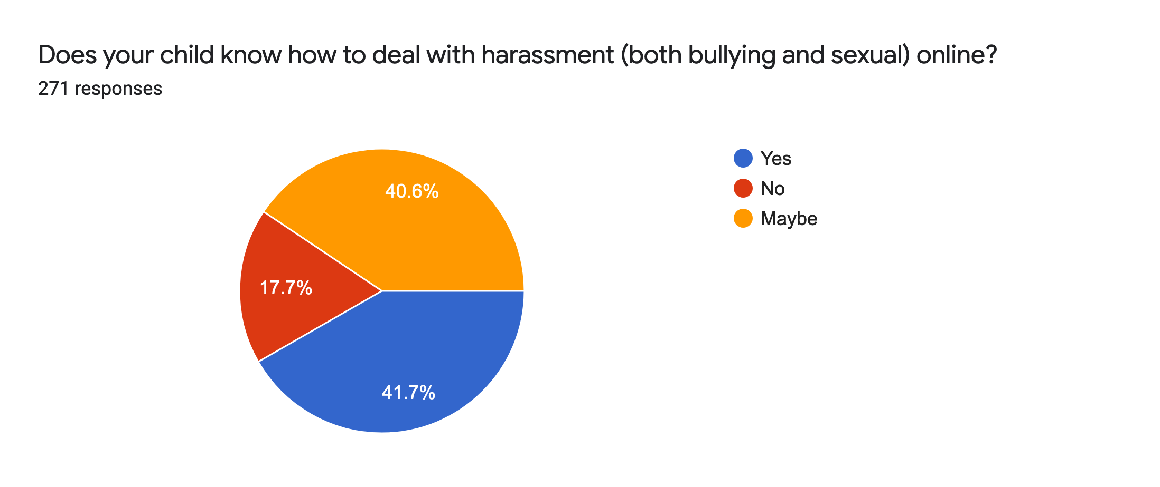

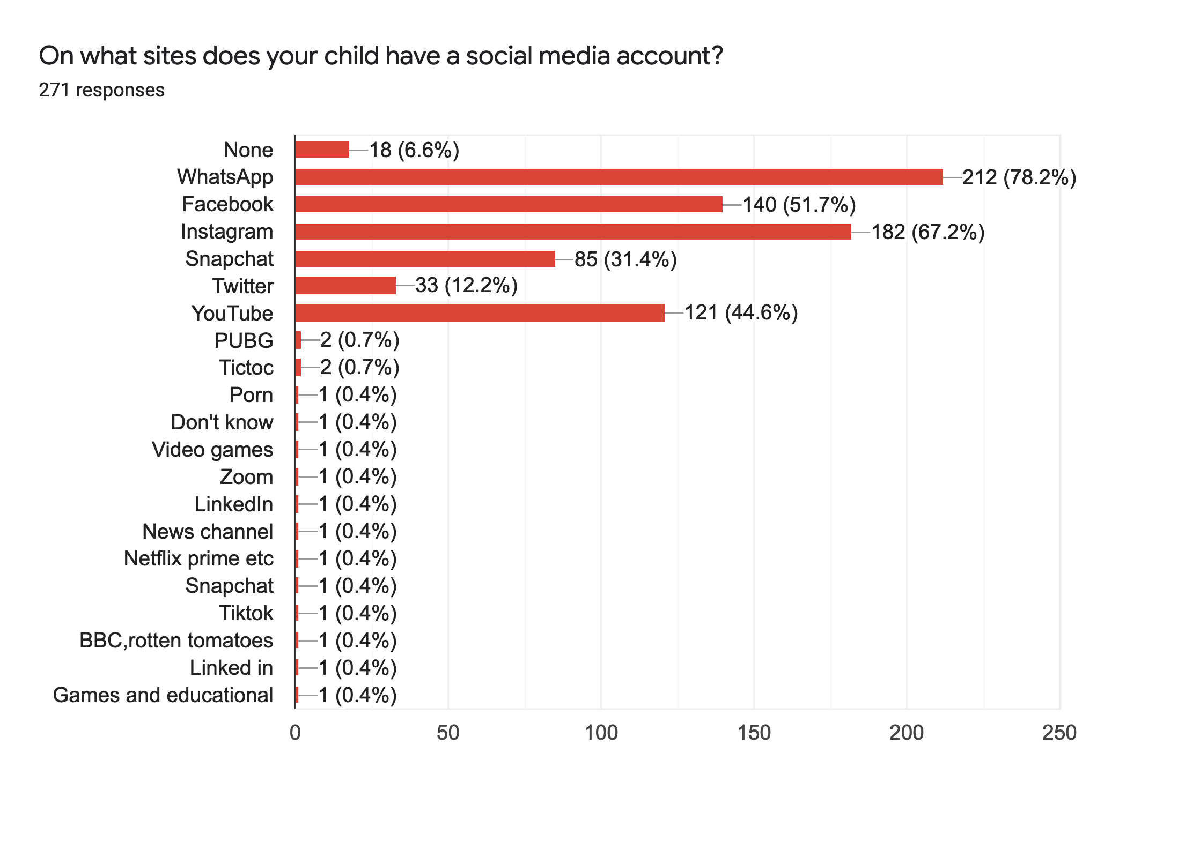

**Tops users:**

1. Whatsapp
2. Instagram
3. FB
4. Youtube
5. Snapchat
6. Twitter

**86% kids received their first gadget at 10.(In metros as well as non metro)**